

PAKISTAN INSTITUTE OF ENGINEERING

AND APPLIED SCIENCES

***Computing Fundamentals & Programming***

**FALL 2020**

Laboratory Exercise-09

Department: Physics

Name: Umar Shifaqat

Serial No. 43

Roll No. BS-20-GB-100864

Date: December 07, 2020

**HOME TASKS**

**HOME TASK 01**

**Modify Self-Activity Task -3 and write a program to count number of digit keys (0 to 9) pressed by the user.**

**INPUT**

#include<stdio.h>

#include<conio.h>

int main(){

char ch;

int count=0;

printf("Type 'e' to terminate the program");

do{

printf("\nType a key =");

ch=getche();

if(ch=='1'||ch=='2'||ch=='3'||ch=='4'||ch=='5'||ch=='6'||ch=='7'||ch=='8'||ch=='9'||ch=='0')

count++;

}while(ch!='e');

printf("\n Digit count = %d", count);

getchar();

return 0 ;

}

**OUTPUT**

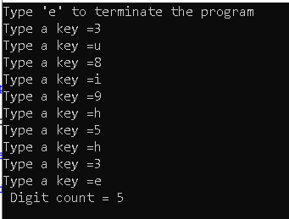

**HOME TASK 02**

**Write a program that ask user to enter a character, the program should check that the character entered by user is;**

**1) a digit**

**2) small letter**

**3) capital letter**

**INPUT**

#include<stdio.h>

#include<conio.h>

int main()

{

char ch;

printf("\nEnter a character : ");

ch=getche();

if(ch>=65&&ch<=90)

printf("\nType:'CAPITAL LETTER'");

else if(ch>=97&&ch<=122)

printf("\nType:'SMALL LETTER'");

else if(ch>=48&&ch<=57)

printf("\nType:'DIGIT'");

else

printf("\nType:'neither a letter nor a digit'");

getchar();

return 0;

}

**OUTPUT**

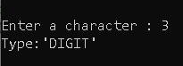

**HOME TASK 03**

**Write a program that allow user to enter as many characters as he/she likes, the program should then display the following statistics**

**1) Total number of characters typed**

**2) How many characters were small letters**

**3) How many characters were capital letters**

**4) How many characters were digits**

**5) How many characters were other than digits and letters**

**INPUT**

#include<stdio.h>

#include<conio.h>

int main()

{

char ch='a',end;

int cpt_let=0,sml_let=0,dig=0,other=0;

printf("Type the key on which you want to end the program: ");

end=getche();

while(3)

{

printf("\nEnter a character : ");

ch=getche();

if(ch==end)

break;

if(ch>=65&&ch<=90)

cpt_let++;

else if(ch>=97&&ch<=122)

sml_let++;

else if(ch>=48&&ch<=57)

dig++;

else

other++;

}

printf("\nNo of 'SMALL LETTERS': %d",sml_let);

printf("\nNo of 'CAPITAL LETTERS': %d",cpt_let);

printf("\nNo of 'DIGITS': %d",dig);

printf("\nNo of characters other than letters and digits': %d",other);

getchar();

return 0;

}

**OUTPUT**

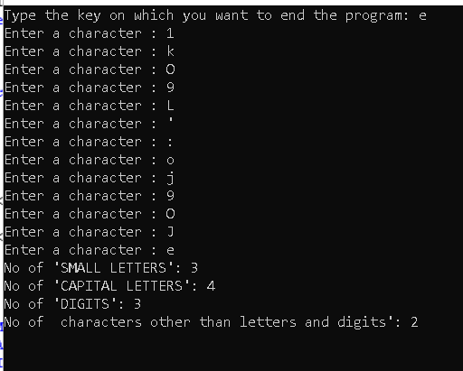

**HOME TASK 04**

**Write a program that lets the user enter his name and roll no. and store it in the form of string.**

**INPUT**

#include<stdio.h>

#include<conio.h>

int main()

{

char name[100],roll_no[100];

puts("Enter your name: ");

gets(name);

puts("Enter your Roll No: ");

gets(roll_no);

puts("\n\n\nYour Name is ");

puts(name);

puts("\nYour Roll Number is ");

puts(roll_no);

getch();

getch();

return 0;

}

**OUTPUT**

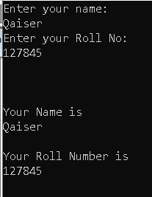

**HOME TASK 05**

**Write a program that uses gets to get a string from the user and stores it in a character array. You need to print the array in reverse.**

**INPUT**

#include<stdio.h>

#include<string.h>

int main()

{

char statement[100];

int x;

puts("Enter a string");

gets(statement);

x=strlen(statement);

puts("The statement in reverse is:\n");

while(x>=0)

{

printf("%c",statement[x]);

x--;

}

getchar();

getchar();

getchar();

return 0;

}

**OUTPUT**

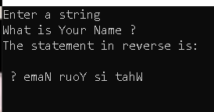

**HOME TASK 06**

**Write a program that initializes a character array using a string from the user, program should print the length of string, first character and last character of the string.**

**INPUT**

#include<stdio.h>

#include<string.h>

int main()

{

char statement[1000];

int x;

puts("Enter a string :");

gets(statement);

x=strlen(statement);

printf("\nThe length of string is : %d",x);

puts("\nThe first character is :");

putchar(statement[0]);

puts("\nThe last character is :");

putchar(statement[x-1]);

getchar();

getchar();

getchar();

return 0;

**OUTPUT**

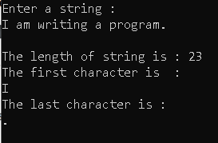

**HOME TASK 07**

**Modify Home Task 6 and allow the user to type an address line that should have some digits such as street umber or house number etc. the program should print the number of character and digits in the string provided by the user.**

**INPUT**

#include<stdio.h>

#include<string.h>

int main()

{

char address[1000];

int x,digit=0,character=0;

puts("Enter your single line address :");

gets(address);

x=strlen(address);

while(x>=0)

{

if(address[x]>=48 && address[x]<=57)

character++;

else if(address[x]>=65&&address[x]<=90||address[x]>=97&&address[x]<=122)

digit++;

x--;

}

printf("\nThe number of characters is %d",character);

printf("\nThe number of digits is %d",digit);

getchar();

getchar();

getchar();

return 0;

}

**OUTPUT**

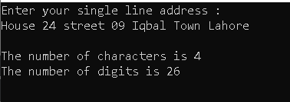

**HOME TASK 08**

**Write a program that lets the user enter a line of text, the program should then ask user the length and starting point of substring from this line, if valid inputs are provided the program should print the sub‐string.**

**INPUT**

#include<stdio.h>

#include<string.h>

int main()

{

char stat[100];

int s,e,i;

puts("\nEnter a statement :");

gets(stat);

puts("\nEnter the position for start of sub-string");

scanf("%d",&s);

puts("\nEnter the length of sub-string");

scanf("%d",&e);

puts("\nThe substring is : ");

for(i=s;i<=s+e;i++)

putchar(stat[i]);

getchar();

getchar();

getchar();

return 0;

}

**OUTPUT**

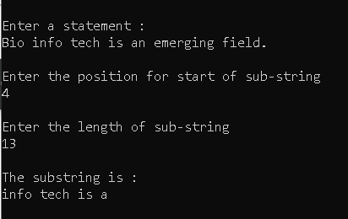

**HOME TASK 09**

**Write a C program to convert lowercase string to uppercase, also count total number of words in a string.**

**INPUT**

#include<stdio.h>

#include<string.h>

int main()

{

char stat[100];

int i=0,length=0;

puts("\nEnter a string :");

gets(stat);

puts("\nThe string in upper case is : ");

puts(strupr(stat));

while(stat[i]!='\0')

{

if(stat[i]!=' ')

length++;

i++;

}

puts("\nThe number of words are");

printf("%d",length);

getchar();

getchar();

getchar();

return 0;

}

**OUTPUT**

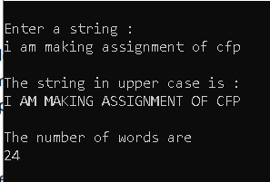

**HOME TASK 10**

**Write a program that lets the user enter a line of text, store the text in a character array, and later print the text as sorted list of alphabets in ascending or descending order.**

**INPUT**

#include<stdio.h>

#include<string.h>

int main()

{

int i,k,l;

char x;

char line[10];

puts("Please enter a line of text upto 100 words \(including spaces\):\n");

gets(line);

l=strlen(line);

i=1;

while(i<l)

{

for(k=0;k<l-i;k++)

{ if(line[k]>=line[k+1])

{

x=line[k+1];

line[k+1]=line[k];

line[k]=x;

}

}

i++;

}

puts("\nThe line in ascending order of alphabets is :");

puts(line);

getchar();

getchar();

getchar();

return 0;

}

**OUTPUT**

